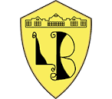
Lord Blyton Primary School

Home Education Due to School Closure

In the event of a school closure we have set out the following home learning expectations for our children.

Organisation:

Each child will be provided with a home learning summary for their year group. This will set out the online learning available for them along with some other activities they should try to carry out. They will be provided with reading books to take home which should be read over the period of closure.

For KS2 children, any recording they wish to do can be done in the home school journals they have been provided with today. If your child is absent and you wish to collect a book for them, they are available at the school office should you wish to collect one before the close of school.

Some further ideas to promote learning are provided at the end of the document which could be used with children of any age!

Additional learning opportunities may be identified by teachers and added to the school website and Facebook page at any time throughout the duration of closure. Please note, teachers are only obliged to reply to any emails you send them during normal working hours.

Lord Blyton Primary School

Home Education Due to School Closure

The following home learning plan has been devised for our Nursery children.

Reading | English | Maths | Personal development
Read a story daily with your child.  Talk about the settings and characters.  Role play (act out) stories.  Practise reading your name and the names of family members.  Identify rhyming words.  Visit bbc.co.uk teach to find nursery rhymes. | Provide opportunities for them to mark make every day, e.g. drawing pictures.  Encourage language and quality discussions with your child. Ask them questions, e.g. what are we going to do today, what can you see outside the window?  Practise cutting skills e.g. using pictures from catalogues or magazines.  Give opportunities for them to follow two-step instructions e.g. put you shoes on and then get your coat. | Sing number rhymes and play counting games. Give them challenges, e.g. how many stairs do we have to climb?  Can you set the table? (With the right number of forks, knives, cups, etc.)  Number spotting in the environment, e.g. door numbers, car registrations, etc.  Talk about shapes, colours and sizes of things.  Visit topmarks.co.uk for ideas:  Shape patterns  Teddy numbers  Shape monsters  Gingerbread man | Toilet training.  Work on self-help skills e.g. putting on and taking off their own coats and shoes.  Keep to a normal routine as much as possible, e.g getting up, meals and bedtimes.  Try to get plenty of fresh air and exercise if possible (even if just in own garden/yard.)  Helping with jobs at home, e.g. washing dishes, making their bed.

If you need any further information or advice about home learning only, then Mrs Hannard or Mrs Lavocah can be contacted directly @ nursery2@lordblyton.s-tyneside.sch.uk or Mrs Hall @ nursery3@lordblyton.s-tyneside.sch.uk
Lord Blyton Primary School
Home Education Due to School Closure

The following home learning plan has been set up for our Reception children.

Reading | English | Maths | Curriculum
Read a Sounds Write book with your child (one per week)  Use the Sounds Write Initial Code app  Do reading in the home environment and (if possible) the local area e.g. labels on food packaging, street signs, etc.  Share a bed time story with your child each evening. | Practise writing your name.  Practise pre-cursive letter formation using the sounds you have been learning.  Take part in activities which with strengthen fine motor skills, e.g. making models with play dough and Lego.  Have a go at writing a story of Jack and the Beanstalk! | Use the Top Marks website to paly counting and ordering games.  Practise number formation.  Listen to and sing the Doubling song on You Tube.  Play board games involving counting and turn taking, such as Snakes and Ladders.  Play ‘Snap’ with playing cards to aid number recognition.  Help prepare meals-chopping and measuring of ingredients. | Look at the Jack and the Beanstalk videos and songs on BBC Teach.  Plant a seed and help it grow.  Ask an older relative about what school was like for them and discuss how things have changed over time.  Draw and label a picture of your family.

If you need any further information or advice about home learning only, then Miss Neilson can be contacted directly @ rec@lordblyton.s-tyneside.sch.uk
Lord Blyton Primary School

Home Education Due to School Closure

The following home learning plan has been set up for our Year 1 children.

Reading | English | Maths | Curriculum
Read daily. Your child will have been given a selection of scheme books and library books. You could check their understanding by asking them some questions based on the texts they have read, using the VIPERS question lists.  Share a bed time story with your child each evening. | Phonics activities have been provided linked to Sounds Write.  Practise handwriting daily.  Practise spellings using the ‘Look, say, cover, write, check’ method. | Children have their own Mathletics logins so this can be used as much as the children would like to (see parent information sheet for how this can be used.)  Encourage children to practise their counting in 2’s, 5’s and 10’s.  Practise days of the week and months of the year so they are able to say them in order.  Look for and name shapes in the environment. | We will be studying famous people in our local area so use this time to research at least two and produce a poster or booklet to show your findings.

If you need any further information or advice about home learning only, then Mrs Butler can be contacted directly @ y1class@lordblyton.s-tyneside.sch.uk

Lord Blyton Primary School

Home Education Due to School Closure

The following home learning plan has been set up for our Year 2 children.
Reading | English | Maths | Curriculum
Reading Eggs – all children have passwords.  Choose one spelling unit each day.  Read at least one book per week – answer questions about the text on the sheet provided. Read them and answer them independently.  Practise the words from the Year 2 list provided – choose 5 per day. You can use different coloured pencils, write them big or small, play puzzles with a grown up – to make practising fun! | Research an Arctic explorer on the internet. Record facts on a mind map.  Write a biography about the Arctic explorer you researched. Try to write in paragraphs with subheadings just like we have done in class. Try to write as much detail as you can – remember to explain why he/she is important and then explain the challenges they faced throughout their journey. | Children will be expected to complete at least one unit of Mathletics each day. There may be special tasks set which must be completed before children can choose.  Using Mathletics – click on explore and then videos. Practise times tables.  Click on Play – choose games such as Rainforest Maths to practise what you have learnt in class. | Science and Geography:  Watch BBC Bitesize  https://www.bbc.co.uk/bitesize/clips/zhrb4wx  The lifecycle of a dandelion.  Watch the video then write in your own words, the lifecycle. Explain the different processes retell the processes in your own words. You can draw pictures and label them to show the sequences.  Watch BBC Bitesize  https://www.bbc.co.uk/bitesize/topics/zx882hv/articles/z3sr4wx  Watch The Arctic Habitat animation.  Write at least 10 facts about the Arctic habitat. You can draw animals or features of the habitat (Tundra) and label them.  Choose a different habitat. Watch the animation.  https://www.bbc.co.uk/bitesize/subjects/z6svr82  Write at least 10 facts about your chosen habitat. Choose an animal from that habitat and write an animal fact file about. Put facts into your own sentences using your own words.  RE - Christianity  Read Top Marks – The Easter Story  https://www.topmarks.co.uk/easter/easterstory.aspx  Retell the Easter Story in your own words. You can draw pictures too. Try to plan each sentence, write it down and check it makes sense before moving on. Try to add as much detail and description as you can in your story to paint the picture in the readers mind.
If you need any further information or advice about home learning only, then Mrs Mattimore can be contacted directly @ y2class@lordblyton.s-tyneside.sch.uk
Lord Blyton Primary School

Home Education Due to School Closure

The following home learning plan has been set up for our Year 3 children.

Reading | English | Maths | Curriculum
Read your reading book daily and answer questions from the VIPERS list that are relevant to the text. These can be recorded on paper if you are able to do this or just done verbally with an adult.  For chapter books, aim to read at least four chapters a day.  Reading Eggs to be used daily. Children can visit the library section and work through comprehension activities at their own pace.  For completed books, write (or word process) a book report. | Practise the spellings from the Year 3 / 4 Statutory Spelling List using the ‘Look, say, cover, write, check’ method.  Use a dictionary or talk to an adult to learn the meanings of these words. | Mathletics to be used daily. Aim to complete at least one unit per day, focusing on topics that have already been taught in class. Once completed, spend at least ten minutes using Live Mathletics to practise your mental recall.  For variety, try the following websites too if you wish:  www.mathsframe.co.uk  www.timestables.co.uk  www.coolmathsgames.co.uk  Learn and revise your times tables up to 12 x 12 and the related division facts. Remember the Maths Frame website is great for your multiplication practice! | Research the following topics in preparation for your return to school, presenting your findings in any way you choose:  Topic: Ancient Egyptians  Local Landmarks  Science: Light  Forces & Magnets  RE: Easter  Symbols of Easter  Art/D&T: Practise your cutting and colouring skills, maybe through doing some Easter crafts or a model linked to one of our topics.

If you need any further information or advice about home learning only, then Miss Georgeson can be contacted directly @ y3class@lordblyton.s-tyneside.sch.uk
Lord Blyton Primary School
Home Education Due to School Closure

The following home learning plan has been set up for our Year 4 children.

Reading | English | Maths | Curriculum
Read your reading book daily and answer questions from the VIPERS list that are relevant to the text. These can be recorded on paper if you are able to do this or just done verbally with an adult.  For chapter books, aim to read at least four chapters a day.  Reading Eggs to be used daily. Children can visit the library section and work through comprehension activities at their own pace.  For completed books, write (or word process) a book report. | Practise the spellings from the Year 3 / 4 Statutory Spelling List using the ‘Look, say, cover, write, check’ method.  Use a dictionary or talk to an adult to learn the meanings of these words. | Mathletics to be used daily. Aim to complete at least one unit per day, focusing on topics that have already been taught in class. Once completed, spend at least ten minutes using Live Mathletics to practise your mental recall.  For variety, try the following websites too if you wish:  www.mathsframe.co.uk  www.timestables.co.uk  www.coolmathsgames.co.uk  Learn and revise your times tables up to 12 x 12 and the related division facts. Remember the Maths Frame website is great for your multiplication check practice! | Research the following topics in preparation for your return to school, presenting your findings in any way you choose:  History: Ancient Greece  Science: Electricity  Sound  Watch relevant programmes on the BBC education sites.

If you need any further information or advice about home learning only, then Mrs Simpson can be contacted directly @ y4class@lordblyton.s-tyneside.sch.uk

Lord Blyton Primary School

Home Education Due to School Closure

The following home learning plan has been set up for our Year 5 children.

Reading | English | Maths | Curriculum
Read daily and answer questions from the VIPERS list that are relevant to the text. These can be recorded on paper if you are able to do this or just done verbally with an adult.  Aim for at least twenty minutes of uninterrupted reading time a day.  Reading Eggs to be used daily. Children can visit the library section and work through comprehension activities at their own pace. | Practise the spellings from the Year 5 / 6 Statutory Spelling List.  Use a dictionary or talk to an adult to learn the meanings of these words.  Use the following websites, paying particular attention to the punctuation and grammar sections:  www.bbc.co.uk/bitesize/subjects/zv48q6f  www.crickweb.co.uk/ks2literacy.html | Mathletics to be used daily. Aim to complete at least one unit per day, focusing on topics that have already been taught in class. Once completed, spend at least twenty minutes using Live Mathletics to practise your mental recall.  Pupils should continue to practise mental recall, e.g. of number bonds, and times tables & related division facts.  For variety, pupils should also visit:  www.bbc.co.uk/bitesize  www.crickweb.co.uk/ks2numeracy  https://uk.ixl.com/math/year-5  www.ilovemathsgames.com | Summer term’s geography topic is South America. Pupils should research South American countries in preparation for this. If they choose to do so, they may present their findings in a format of their choice, which we will look at upon their return to school.

If you need any further information or advice about home learning only, then Mr Stead can be contacted directly @ y5class@lordblyton.s-tyneside.sch.uk

Lord Blyton Primary School
Home Education Due to School Closure

The following home learning plan has been set up for our Year 6 children.

Reading | English | Maths | Curriculum
Read your home reading books daily and answer questions from the VIPERS list that are relevant to the text. These can be recorded on paper if you are able to do this or just done verbally with an adult.  Aim for at least twenty minutes of uninterrupted reading time a day.  Reading Eggs to be used daily. You can visit the library section and work through comprehension activities at your own pace.  You may wish to look online at past reading SATs papers, having a go at reading them within the given time and chatting with an adult about how you would answer the questions. These can be found at www.satspapers.org.uk  The mark schemes are available for you to check your answers! | Practise the spellings from the Year 5 / 6 Statutory Spelling List. Use a dictionary or talk to an adult to learn the meanings of these words.  Complete at least 2 quizzes a day at https://www.educationquizzes.com/ks2/english/  (Focus on topics you are not confident with.)  You may wish to look online at past GPS SATs papers. These can be found at www.satspapers.org.uk. If you come across any questions you aren’t sure of, or terminology you can’t remember the meaning of, then research and practise!  The mark schemes are available for you to check your answers!  Other useful sites to aid revision:  https://www.topmarks.co.uk/english-games/7-11-years/spelling-and-grammar | Mathletics to be used daily. Aim to complete at least one unit per day, focusing on topics that have already been taught in class. Once completed, spend at least twenty minutes using Live Mathletics to practise your mental recall.  You may wish to look online at past Maths SATs papers. These can be found at www.satspapers.org.uk. Remember Paper 1 is the Arithmetic paper. Any that you struggle with on here, have a practice using similar questions until you feel more confident. Papers 2 and 3 will have reasoning and problem-solving questions for you to have a go at. Talk through how you would tackle these with an adult. The mark schemes are available for you to check your answers! | If you would like to do any written work during the closure, can I please ask you consider doing any of the following (either handwritten or word-processed):  - A project about a North American country of your choice  - A retelling of the Easter story, told from the perspective of Jesus or his mother Mary.  - An explanation text about how exercise, diet and sensible life choices impact on our wellbeing.  - A letter to Boris Johnson stating your views on the school closures and their impact on you!

If you need any further information or advice about home learning only, then Mrs Wales can be contacted directly @ y6class@lordblyton.s-tyneside.sch.uk (I know SATs have now been cancelled but teacher assessment is still of great importance!)

Lord Blyton Primary School

Home Education Due to School Closure

The following home learning ideas have been suggested by Mr Gilmore to ensure all of our children stay fit and healthy during closure!
NURSERY & KS1 CHILDREN | KS2 CHILDREN
Joe Wicks workout for kids  https://www.youtube.com/watch?v=d3LPrhI0v-w  https://www.youtube.com/watch?v=EXt2jLRlaf8  https://www.youtube.com/watch?v=mhHY8mOQ5eo  There are others (simply type ‘Joe Wicks workout for kids’ in You tube.)  Aim to complete 60 mins of exercise throughout each day - remember this can be done through play as well as "sporting activities.” It also doesn't have to be 60 mins in one go. Even helping your parents out with household chores would count towards it!!  If you are able to access the outside (i.e. garden) lots of exercise and activities can take place there with or without equipment. | Aim to complete 60 mins of exercise throughout each day - remember this can be done through play as well as "sporting activities." It also doesn't have to be 60 mins in one go!! (Even helping your parents out with household chores would count towards it!!)  Research and understand the rules of tennis during gameplay in line with the topic you are currently studying.  There are videos on YouTube of tennis matches where you can see the rules applied in a professional game (you don't need to watch the whole game, you'll be there for hours!)  If you are able to access the outside (i.e. garden) lots of exercise and activities can take place there with or without equipment.

SOME USEFUL LINKS AND WEBSITES

To support reading and writing:
www.oxfordowl.co.uk
www.pobble365.com
www.literacyshed.com
https://www.educatorstechnology.com/2018/02/19-educational-websites-to-enhance.html
Reading Vipers question can be found at:
https://www.literacyshedblog.com/uploads/1/2/5/7/12572836/ks1_reading_vipers.pdf
https://www.literacyshedblog.com/uploads/1/2/5/7/12572836/ks2_reading_vipers.pdf

To support maths learning:
https://www.thestudentroom.co.uk/revision/mathematics/useful-maths-websites
mathshko.com
mathsbot.com
www.solvemoji.com
nrich.maths.org
www.mathszone.co.uk

To support all subjects:
www.bbc.co.uk/schools
twinkl.co.uk

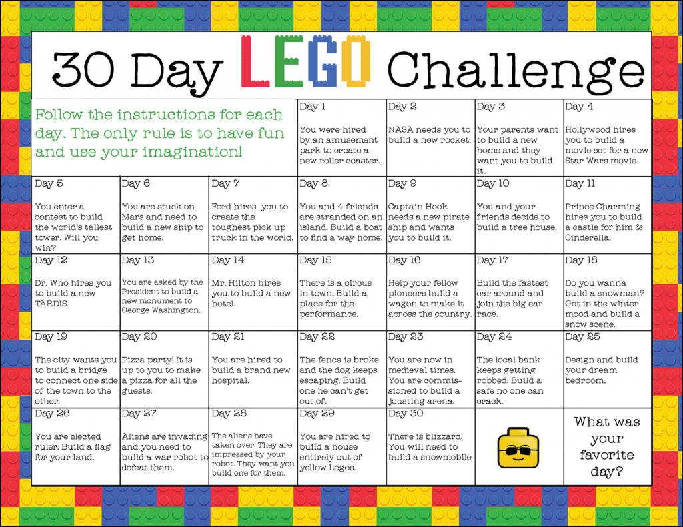
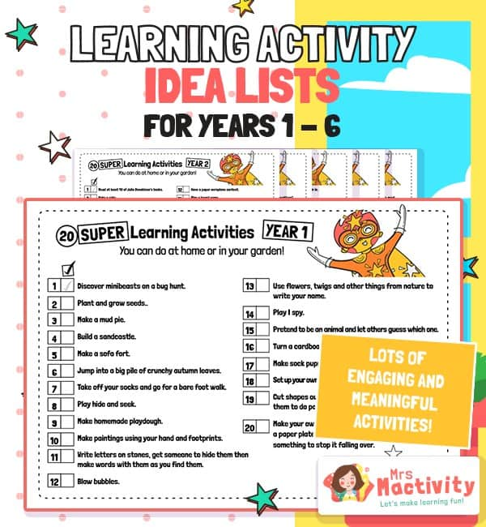
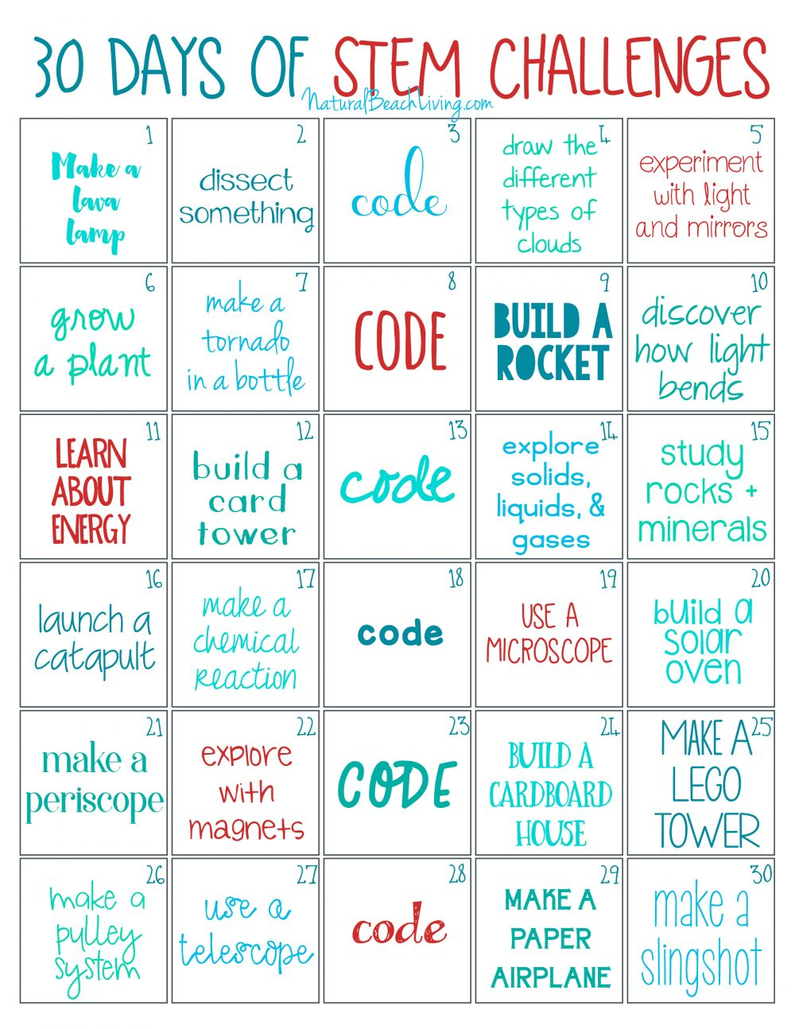

Our children are a part of history right now so why not get them to make a time capsule?
Write a letter to your future self. Where do you live? What is currently your favourite toy, book and song? What are your hobbies and interests now? What are your hopes and dreams for the future?

Draw and label a picture of your family now and maybe include some real photographs too.

Find a piece of clothing you no longer wear and a toy or book you no longer play with.
Get newspapers and magazines to cut out articles about the main news stories to share with your future selves.
Pop it all together in an old shoe box or container and store it in the loft to rediscover in years to come!

